Topic 1: Session Hijacking PoC
Session Hijacking via Cookie Replay due to Server Trust in Session ID

1. Objective of the PoC
To demonstrate that possession of a valid session cookie alone is sufficient to impersonate an authenticated user, due to server-side trust placed entirely in the session identifier.

2. Target Application Details
- Website: https://www.adafruit.com
- Category: E-Commerce
- Type: Live E-Commerce Website
- Observation Type: Conceptual session behavior analysis
- Note: No exploitation or vulnerability disclosure was performed on the live site.

3. Pre-Conditions
- Victim user is already authenticated.
- Session identifier is stored client-side as a cookie.
- Server relies solely on the session cookie to identify the user.
- No secondary validation such as IP binding, user agent binding, or step-up re-authentication.

4. Proof of Concept – Sequential Execution Log
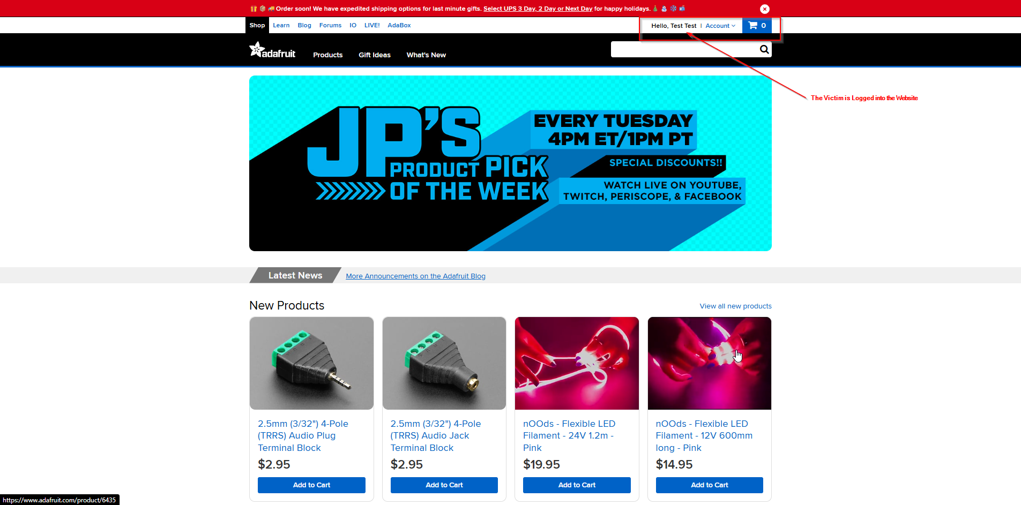
Figure 1.1 – Victim Authenticated Session
- A legitimate user is logged into the Adafruit website.
- The website displays a personalized greeting (“Hello, Test Test”).
- This confirms the existence of an active, authenticated session.

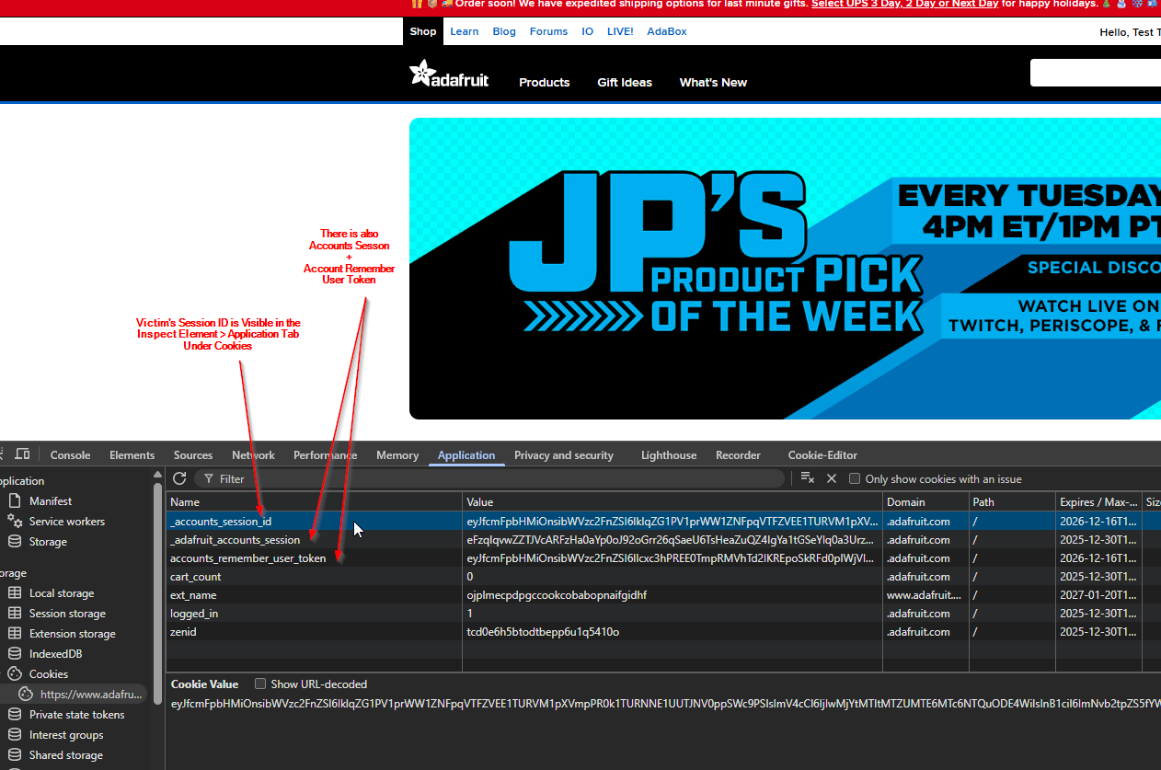
Figure 1.2 – Identification of Session Cookies
- Browser developer tools are used to inspect stored cookies.
- Session-related cookies such as _accounts_session_id and remember_user_token are present.
- These cookies represent the authenticated session state.

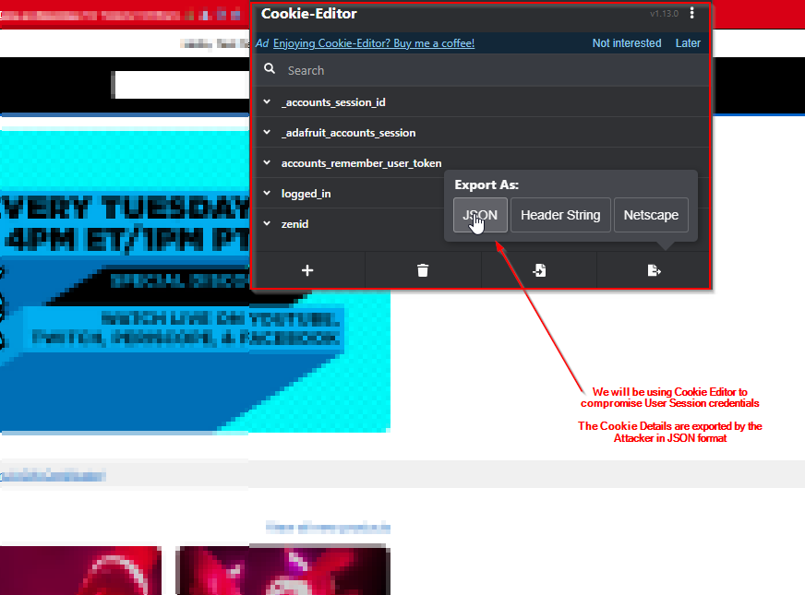
Figure 1.3 – Extraction of Session Cookies
- The session cookies are exported using a browser cookie management tool.
- Cookies are saved in a portable format (JSON).
- This action simulates unauthorized session reuse without interacting with the server.

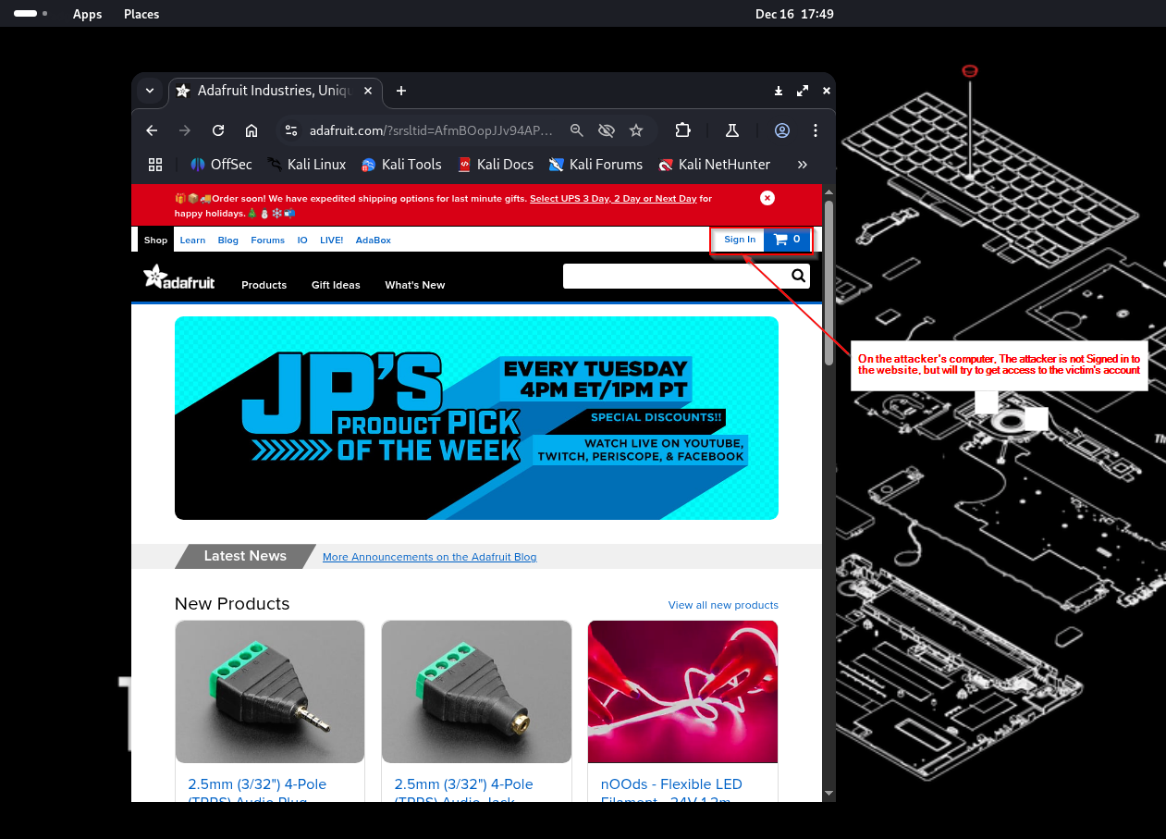
Figure 1.4 – Attacker Browser Without Authentication
- A separate browser instance is opened with no active login.
- The website displays the “Sign In” option.
- This confirms the attacker has no valid session initially.

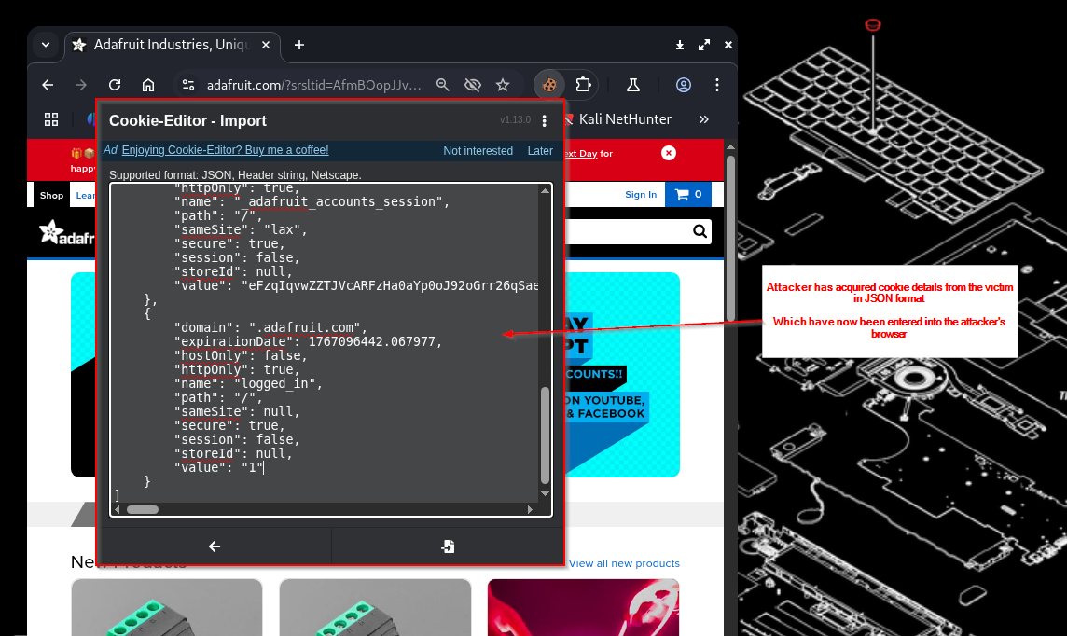
Figure 1.5 – Import of Stolen Session Cookies
- The previously extracted session cookies are imported into the attacker’s browser.
- The cookie values now match those of the victim’s session.
- No login credentials are entered during this step.

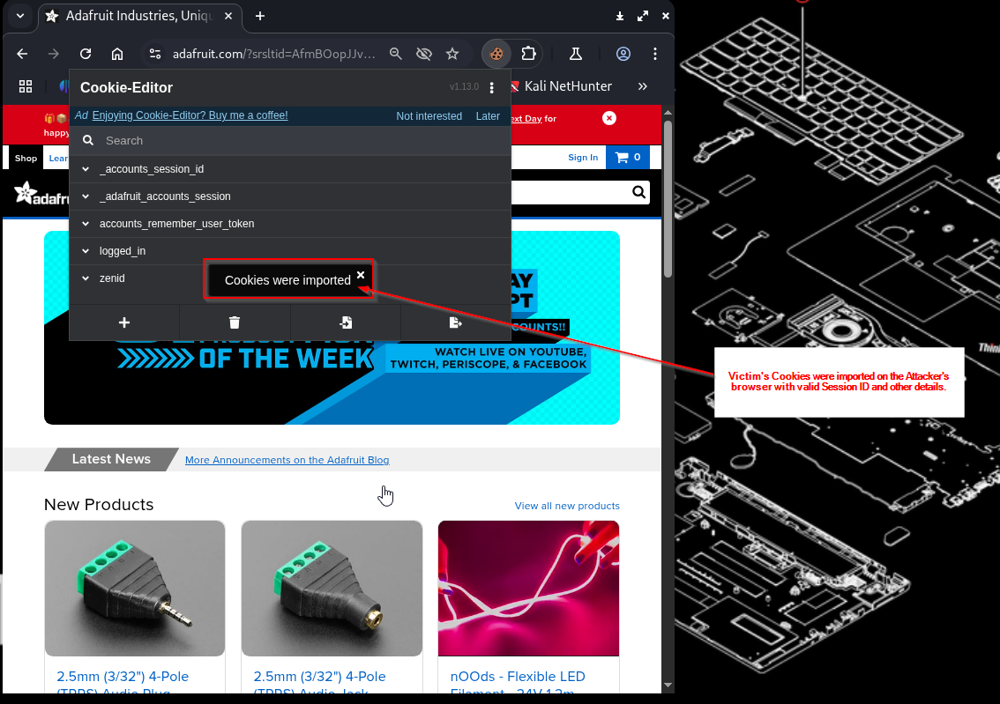
Figure 1.6 – Injection and Use of Session Cookies
- The attacker’s browser automatically includes the imported cookies in subsequent HTTP requests.
- The server accepts the cookies as valid.
- No anomaly or challenge is triggered by the server.

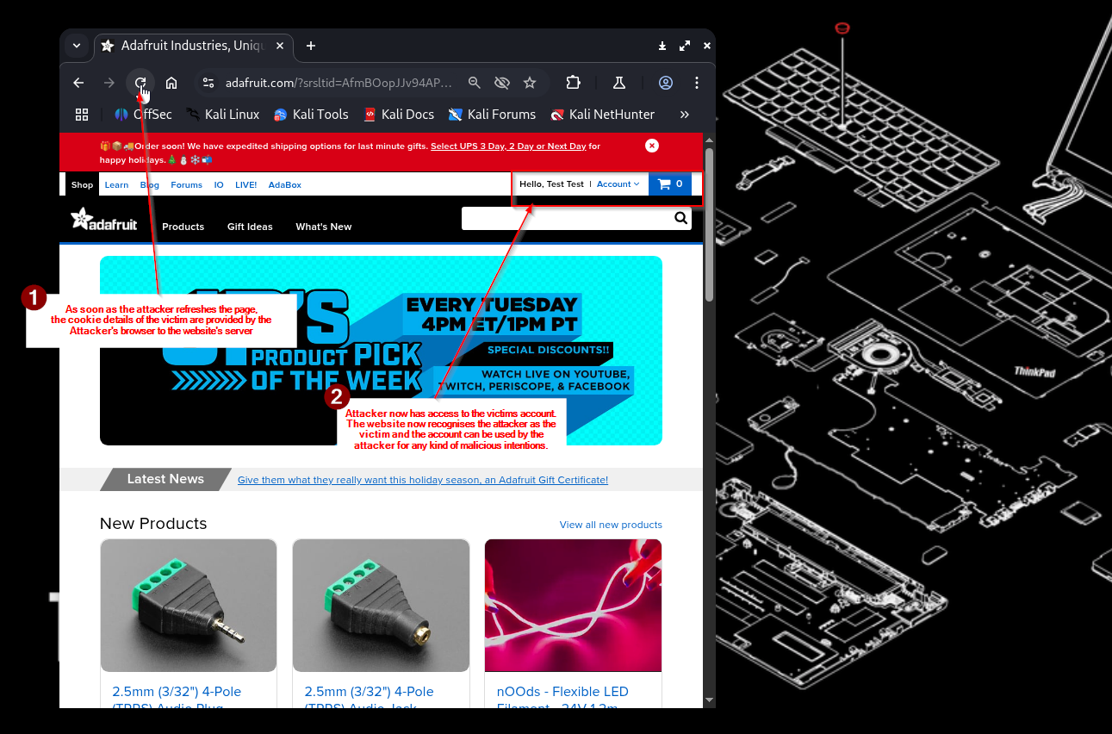
Figure 1.7 – Successful Session Hijacking
- The application recognizes the attacker as the authenticated victim.
- Personalized content and account access are granted.
- Authentication is fully bypassed using only the session cookie.

5. Result
The PoC confirms that:
- The server performs no independent verification beyond session identifier.
- Anyone in possession of a valid session ID is treated as the authenticated user
- No credentials, MFA, or revalidation are required

6. Security Impact
- Unauthorized account access
- Exposure of personal or transactional data
- Complete account takeover

7. Key Insight
This is not a browser flaw.
The browser behaves exactly as designed.
The trust boundary is exploited whenever session identifiers are exposed, reused or improperly protected.

8. Attack Classification:
Execution-based session hijacking via authenticated session reuse.

9. Conclusion
Session hijacking occurs when applications equate session possession with authentication. Without additional validation or session regeneration mechanisms, stolen session cookies directly result in account compromise.

10. References
- PortSwigger Web Security Academy – Session Hijacking
https://portswigger.net/web-security/session-management/session-hijacking
Referenced for understanding session hijacking concepts, attacker workflows, and real-world exploitation scenarios.

- OWASP Session Management Cheat Sheet
https://cheatsheetseries.owasp.org/cheatsheets/Session_Management_Cheat_Sheet.html
Referenced for best practices related to session identifiers, cookie handling, and session lifecycle management.

- RFC 6265 – HTTP State Management Mechanism
https://datatracker.ietf.org/doc/html/rfc6265
Referenced for authoritative specifications on HTTP cookies, scope, transmission, and security considerations.

- Burp Suite Professional Documentation – Proxy & Repeater
https://portswigger.net/burp/documentation
Referenced for session interception, cookie analysis, and request replay methodology.

- Chromium Project – Cookie Handling Behaviour
https://www.chromium.org/developers/design-documents/network-stack/cookies
Referenced to understand browser-side cookie storage and automatic transmission behaviour.

- Adafruit Website (Observation Only)
https://www.adafruit.com
Referenced strictly for passive observation of session handling behaviour in a live web application. No exploitation was performed.

All references were used for educational analysis and controlled testing only. No unauthorized testing was conducted against live users or systems.

